

Automotive Door Control System Design

Dynamic Design

Nora Elhennawy | EGYFWD | 4-10-22

# ECU1

## State Machine diagram

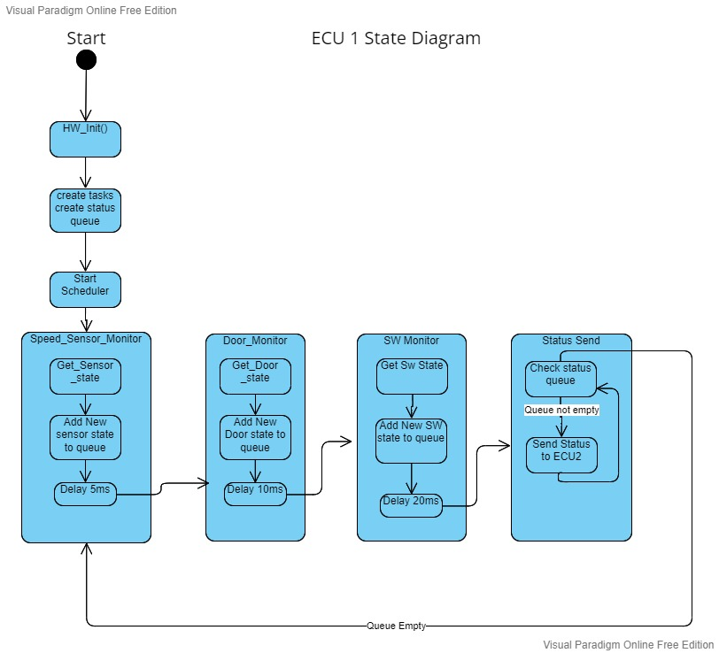

## ECu1 Components State diagrams

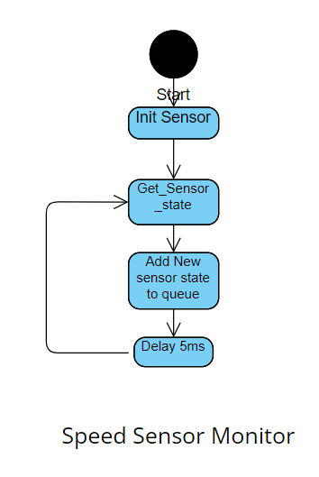 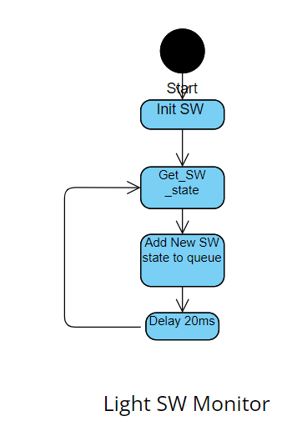 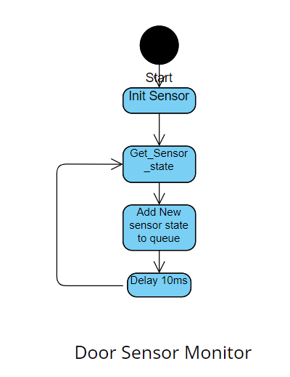

## ecu1 sequence diagram

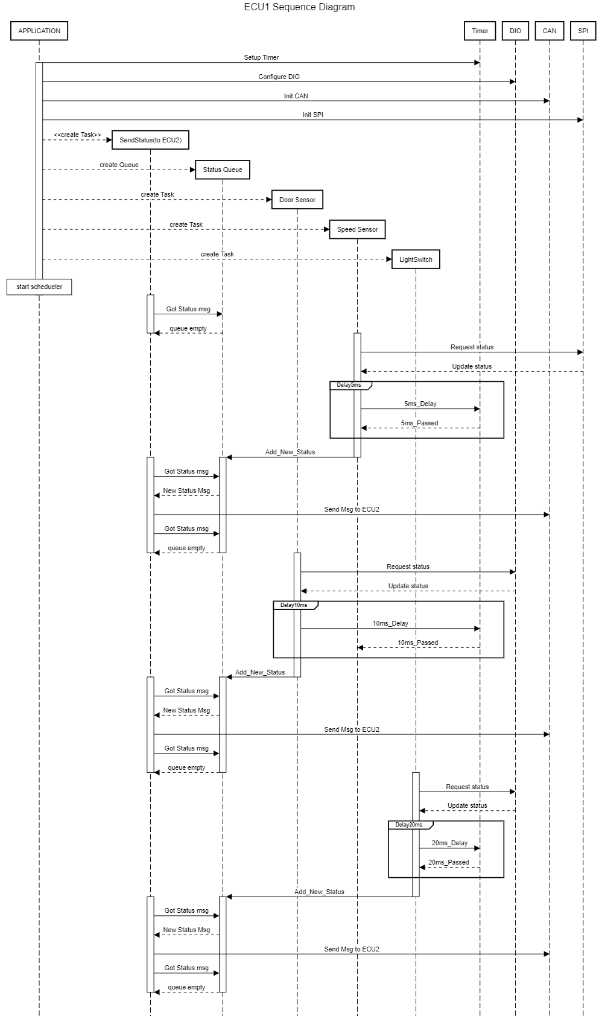

## ecu1 cpu load

System has 4 tasks:

Door_Sensor_Monitor : exec time 15 us , period=10 ms

Speed_Sensor_Monitor : exec time 15us , period=5ms

Light_SW_Monitor : exec time 15 us, period=20 ms

Send_Status_Task : exec time 18 us, period=5ms

HyperPeriod =20 ms.

CPU Load = ((0.015*2+0.015*4+0.015+0.018*4)/20) x 100 = 0.885 %

## ecu2 state diagram

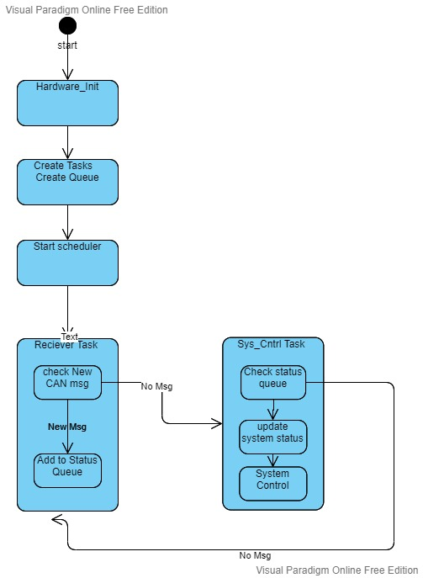

## ecu2 components state diagram

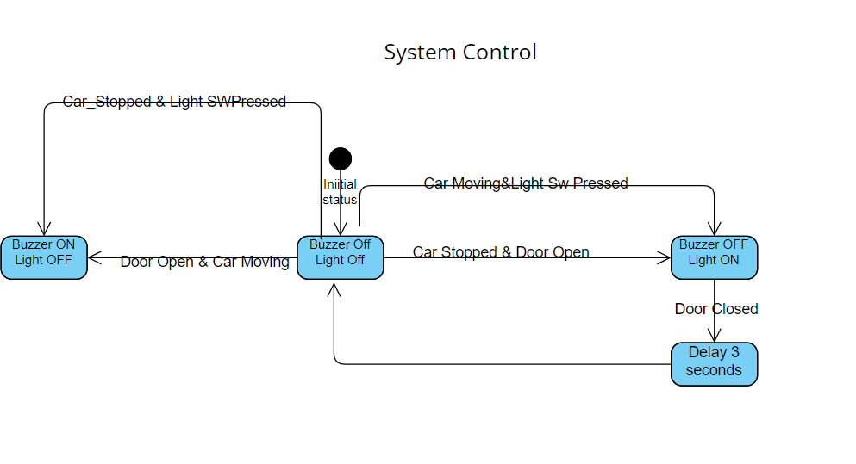

## ecu2 sequence diagram

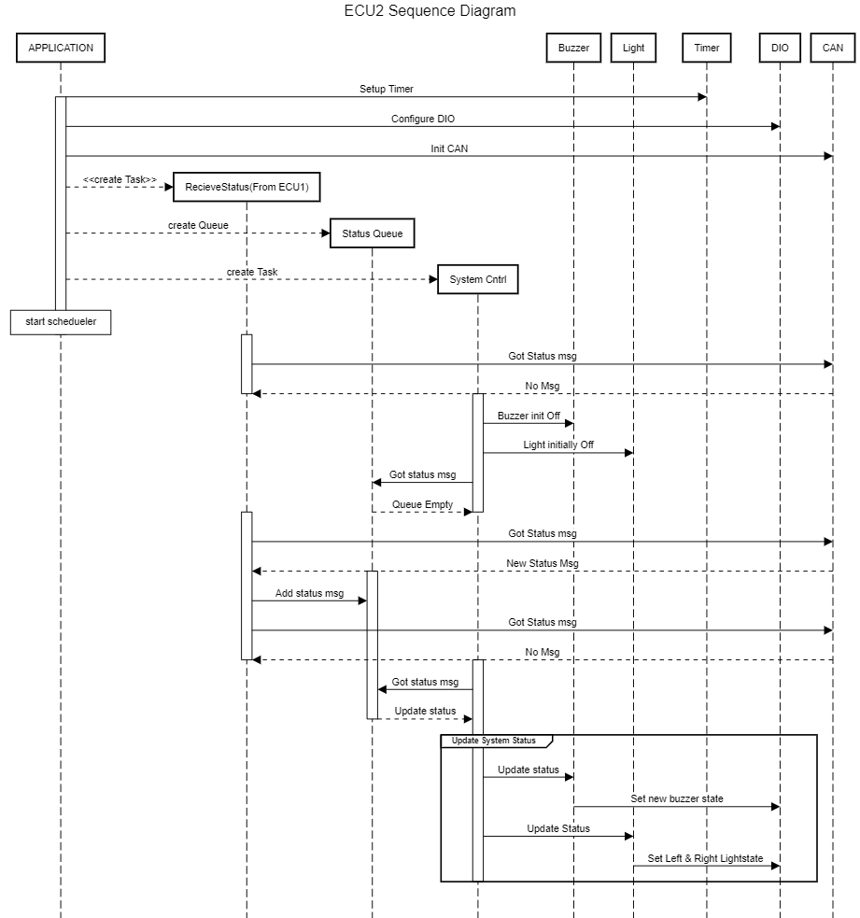

## ecu2 cpu load

System has two tasks :

RecvStatus_task : exe time= 18 us , period =5ms

SystemCntrl: exe time =15 us, period =5ms

Hyper period =5ms

CPU Load = ((0.015+0.018)/5)x100 =0.66 %

NOTE: task exe time was assumed according to real exec time for similar tasks form RTOS project.

## system bus load

Speed Sensor Status (5ms)=200 message/second

Door Sensor Status(10ms)=100 message/second

Light Sw Status(20ms) = 50 message /second

Total messages on bus = 350 message/second.

Assuming simple can protocol with 125 bit frame length at speed 500kbit/s:

Bus Load= ((350*250)/(1000*1000))*100=8.75%